BIT 4107 – Mobile Application Development
ENHANCED PROFESSIONAL STUDENT LOGBOOK
Student Name: Beyonce Ngao
Admission Number: BIT/2024/74225
School/Faculty: School of Computing and Informatics
Programme: Bachelor of Information technology
Academic Year: Year 3
Semester: 2
Lecturer: Nyoro Michael
Phone Number: 0793365595

Instructions
This logbook is used to document weekly learning activities, practical exercises, skills acquired, challenges encountered, solutions applied, and reflections. Students should complete all sections every week.
Each week to follow remarks in week 1 section.

Autogenerated Table of content

Week 1: Introduction to Mobile Application Development
Smart Retail Pro is a mobile inventory and sales management application designed to help retail businesses manage their products, monitor stock levels, and simplify daily operations. The app provides a centralized platform where a manager can view inventory, add products, track business information, and make better decisions through an easy-to-use mobile interface.

Practical Activities Undertaken
only screenshots needed and labeling
Screenshots/Evidence Attached (Yes/No)

Tools/Software Used
Figure 1: Visual Studio Code
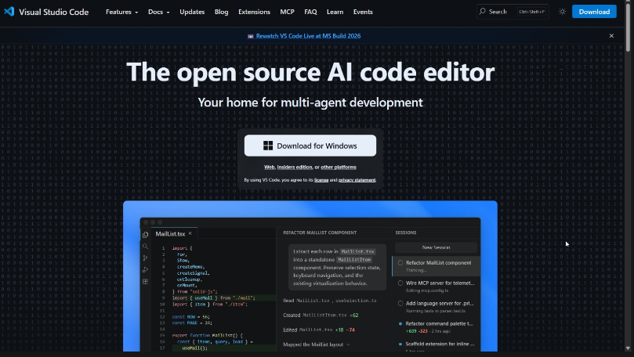
Figure 2: React Native
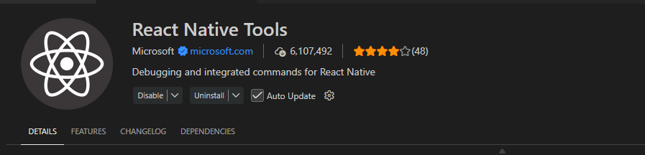

Personal Reflection
Visual Studio Code was selected as the Integrated Development Environment (IDE) because it provides a lightweight and efficient workspace for writing, editing, debugging, and managing React Native application code. React Native was chosen as the development framework because it enables the creation of cross-platform mobile applications using JavaScript from a single codebase.

Week 2: Mobile Development Environment
Figure 3: Vs Code Terminal to execute the extensions

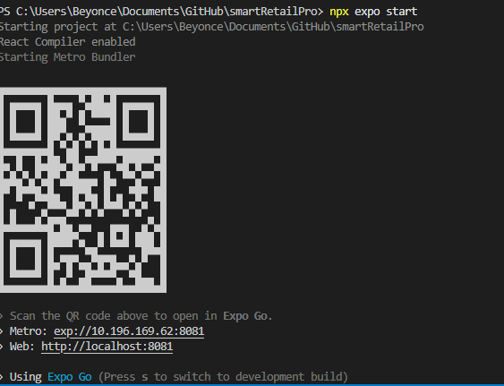

Personal Reflection
Setting up the React Native environment exposed the complexity of mobile dependencies. Overcoming initial configuration path errors in VS Code and successfully launching the Metro bundler alongside the Android emulator was a major technical milestone, establishing a stable sandbox environment essential for developing the retail application

Week 3: User Interface Design
Figure 4: The Login Screen

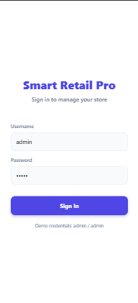
Figure 5: Dashboard Screen
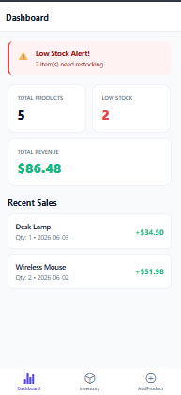
Figure 6: Inventory Screen
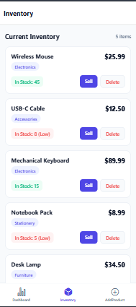

Figure 7: Add product Screen
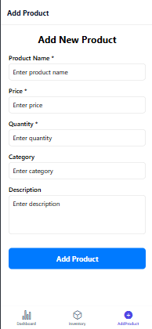
Personal Reflection
Styling with Flexbox in React Native felt familiar yet distinct from traditional web CSS. Translating raw UI mockups into fully structured primitive components in VS Code taught me how native layout engines operate, resulting in a clean, responsive prototype layout for the inventory screen.

Week 4: Event Handling and User Interaction
Figure 8:
Implementing event handlers like onPress for the "Sell" button helped me bridge the gap between static layouts and dynamic user interaction. Managing button states smoothly ensures a responsive and intuitive retail user experience.

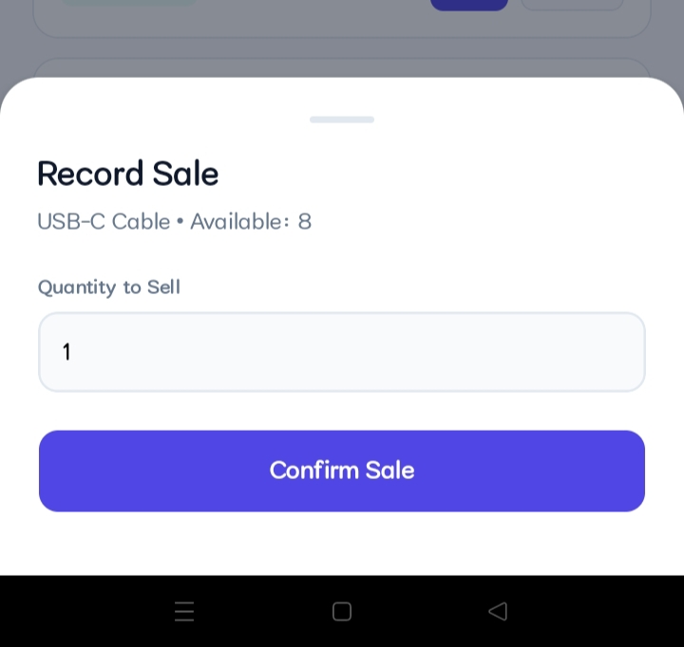
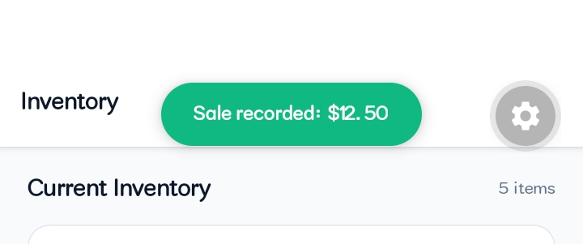

Week 5: Data Management
Figure 10:
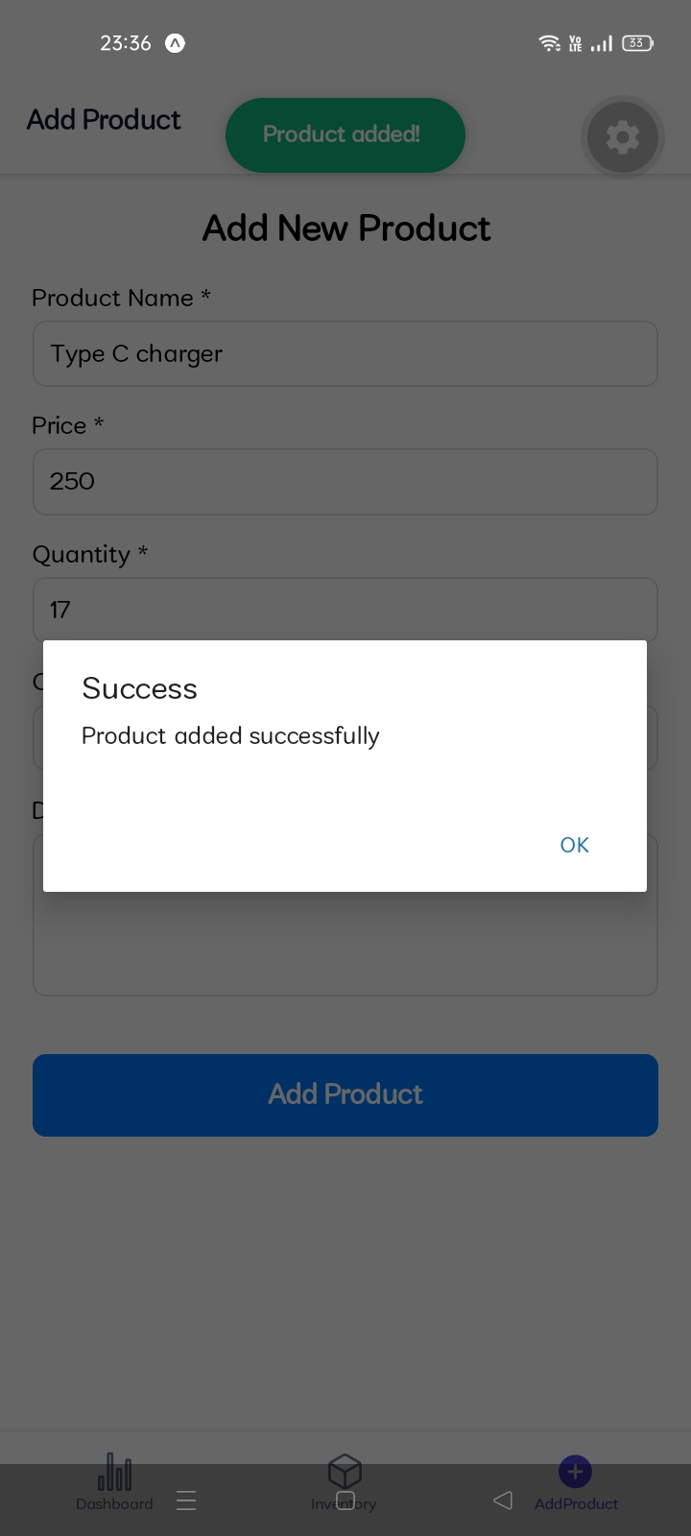
Figure 11:
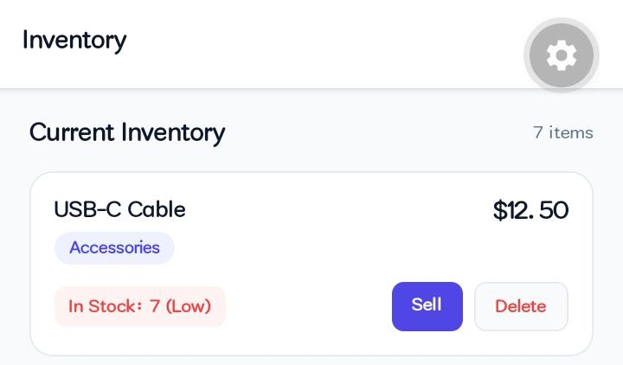

Personal Reflection
Managing data within Smart Retail Pro clarified how information flows between components. Implementing controlled form inputs allowed me to handle product arrays, trigger success alerts, and dynamically calculate low-stock metrics. This built a vital foundation for local state management prior to full database integration.".

Week 6: Networking and APIs

Same as week 1

Week 7: Application Architecture

Same as week 1

Week 8: Project Planning

Week 9: Device Features and Sensors

Same as week 1

Week 10: Notifications and Background Services

Same as week 1

Week 11: Mobile Security

Same as week 1

Week 12: Testing and Debugging

Same as week 1

Week 13: Application Deployment

Same as week 1

Week 14: Final Project Presentation

Same as week 1

Semester Project Tracking

Project Title

Project Objectives

Project Requirements

Development Milestones

Testing Results

Lessons Learned

Future Improvements

End of Semester Reflection

Summary of Skills Acquired

Most Interesting Topic

Major Challenges Faced

How Challenges Were Overcome

Professional Growth Achieved

Overall Course Experience

Final Approval
Student Name: __________________________
Student Signature: ______________________
Date: _________________________________
Lecturer Name: _________________________
Lecturer Remarks: _____________________
Date: _________________________________

